Analysis Report

1. The purpose of this analysis is to help Pewlett Hackardcompany figuring out how they are going to replace all the baby boomers as they are retiring at a rapid rate. First, Pewlett Hackardneeds to find out how many baby boomers are going to retire in the next few years and how many vacancies will they leave. To do that, we will generate a list of all employees who are eligible retirement. See the table below.

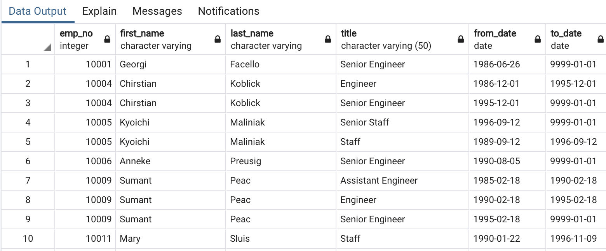

1. The result that I got from both deliveries are:

* created a Retirement Titles table that holds all the titles of employees who were born between January 1, 1952 and December 31, 1955, who are eligible retirement.
* Created a Unique Titles table that holds a list of employees who were born between January 1, 1952 and December 31, 1955, with their most recent title.

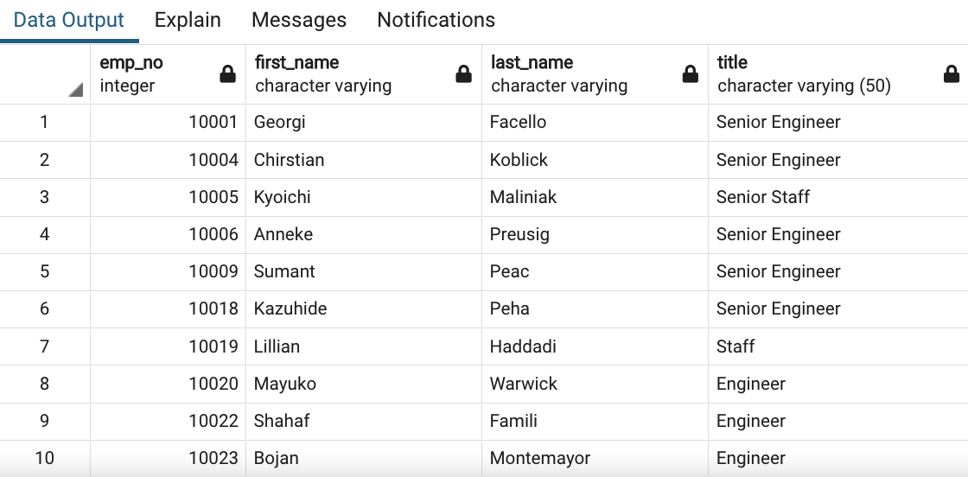

* Created a Mentorship Eligibility table that holds the employees who are eligible to participate in a mentorship program.

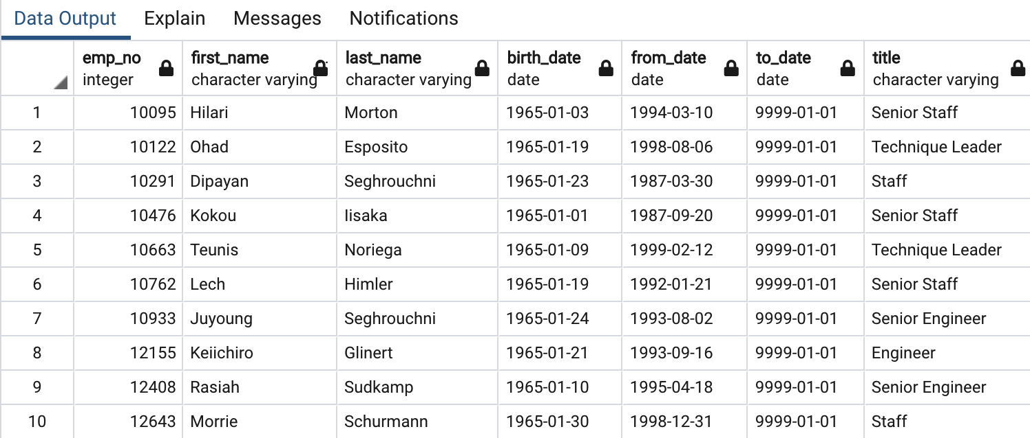

* To create the Mentorship Eligibility table, I joined the Employees, the Department Employee, and the Titles tables. Then I filtered the data on the to_date column, and on the birth_date columns to get all the employees whose birth dates are between January 1, 1965 and December 31, 1965.